**Task 06**

**Name: Abdullah Butt Roll Number: 018**

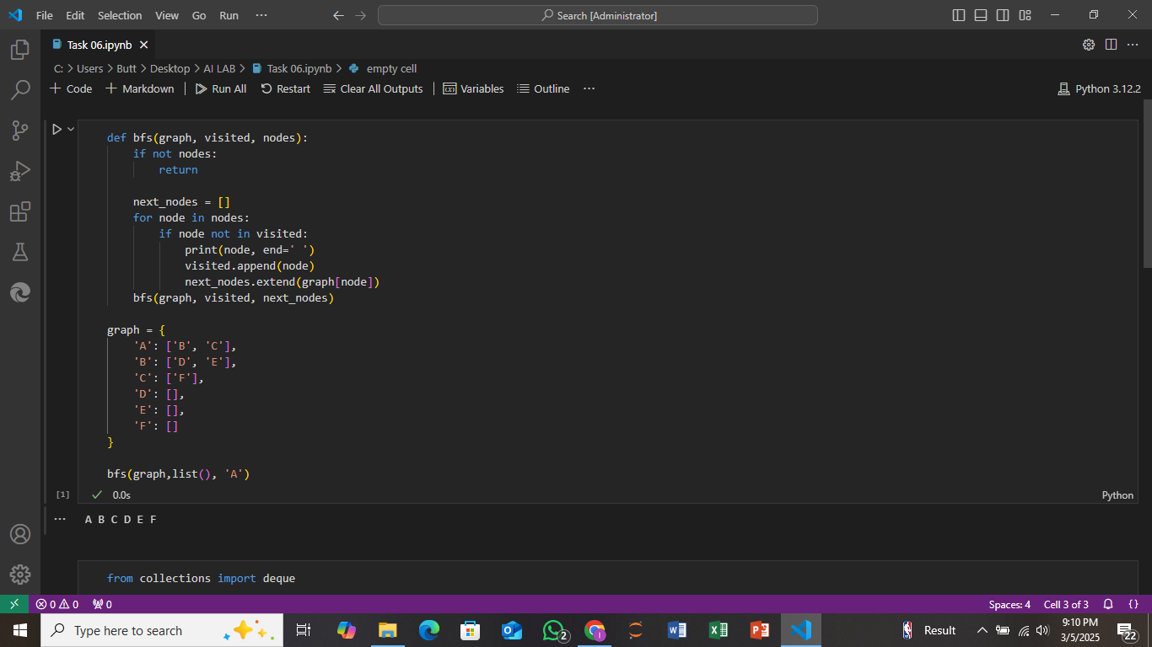

**Explaination:**

There is the implementation of BFS with the help of nodes. In this we create a function of BFS and pass 3 parameters (Graph, visited, nodes) graph consist on the details of nodes visited contain the nodes pop from the queue. Firstly, it check the existence of node if the node exist or not then it execute a for loop and access the node in nodes if that node not in visited then print that node then space and append the visited with that node for execute this code we call the function by its name and give the value of parameters

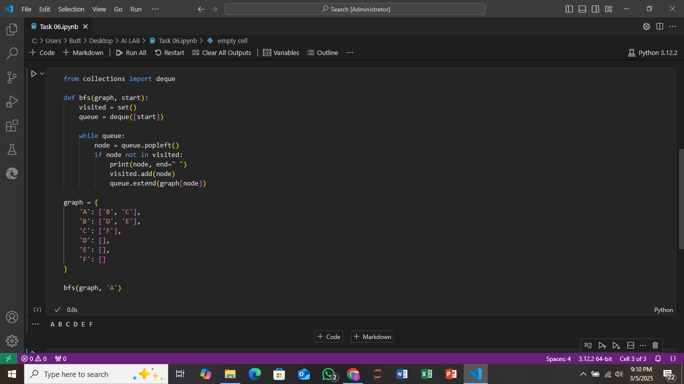

**Explaination:**

There is the implementation of BFS with importing Queue . In this we create a function of BFS and pass 2 parameters (Graph, start) graph consist on the details of nodes and start tell from which node we start the program. visited contain the nodes pop from the queue. Firstly we create visited set then we call a while loop if the node not in visited we append it in it for execute this code we call the function by its name and give the value of parameters